Nelwyn Escodo

Activity 1

***Han* Solo**

Quick thinking and skilled with a blaster,

*Han* Solo is a smuggler, space pirate, and captain of

The Millennium Falcon. When he and his Waukee

Skywalker and Obi-Wan Kenobi, *Han* becomes

Involved in the rescue of Princess Leia.

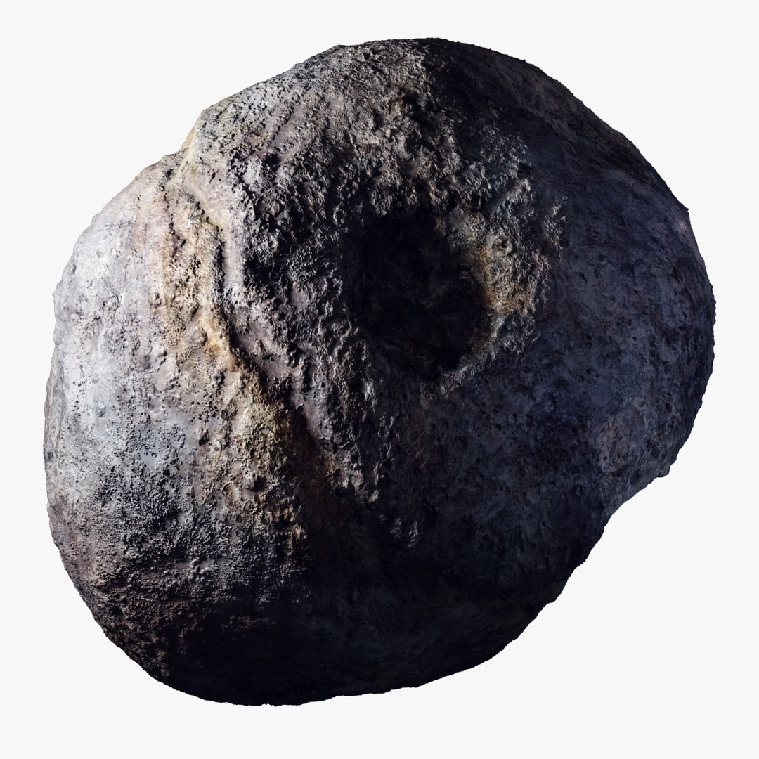*Han* falls in love with Leia and is flyboy talents.

No longer a reckless adventurer, *Han* becomes one

Of the Rebellion’s most courageous heroes

1. Han Solo
2. Chewbacca
3. Luke
4. Skywalker
5. Obi-Wan Kenobi
6. Princess Leia
7. Master Yoda